[DCO-2494] Business Channel - Authenticated customer login Username contrast issues Created: 01/May/24 Updated: 03/May/24
Status: | In External Review
Project: | Journey Manager
Components: | None
Affects versions: | None
Fix versions: | Accessibility

Type: | Story | Priority: | None
Reporter: | Sanya Khandhuja | Assignee: | Fusi Olateru
Resolution: | Unresolved | Votes: | 0
Labels: | Business-self-serve
Remaining Estimate: | Not Specified
Time Spent: | Not Specified
Original estimate: | Not Specified

Attachments: | image-20240501-192409.png
QA Bug Count: | 0
Days Open: | 1 days
Bug Count: | 0
Hours Variance: | 0
Hours Remaining: | 0
Hours Target PMO: | 0
Sprint:
Days Open: | 1

Description

The login page for existing users contains description text below the “username” label that lacks sufficient contrast. The contrast between the foreground and background text colors is insufficient (2.4:1), falling short of the 4.5:1 required for regular text.
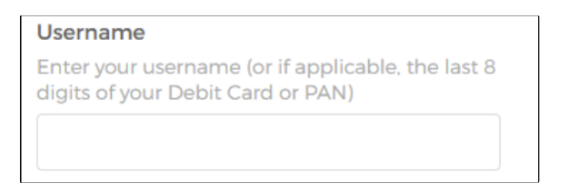
■ Recommendation: Change all problematic foreground/background pairings to higher contrast ratios that meet or exceed the required minimum.

Comments

Comment by Fusi Olateru [ 03/May/24 ]
Okta
Generated at Wed May 08 16:16:43 UTC 2024 by Ian Hicks using Jira 1001.0.0-SNAPSHOT#100252-rev:001dd3b46b0e2bd1b1649b341ae80995ab509a2b.

